VIRTUAL DATA SCIENCE WITH PYTHON INTERNSHIP
Week 5 — Final Project Report
Comprehensive Data Science Project Reporting and Strategic Recommendations
Titanic Passenger Dataset — End-to-End Analysis
Consolidating Weeks 1–4: Data Acquisition & Cleaning · Advanced Visualization · Statistical Hypothesis Testing · Machine Learning Modeling
Prepared using Python, Pandas, NumPy, SciPy, Scikit-learn, Matplotlib, Seaborn
Environment: Google Colab
Report Date: September 22, 2026

Table of Contents

1. Executive Summary
This report presents the consolidated findings of a four-week, end-to-end data science project completed on the Titanic passenger dataset as part of the Virtual Data Science with Python internship. The project spans the full analytics lifecycle: data acquisition and cleaning, exploratory and advanced visualization, statistical hypothesis testing, and predictive machine learning modeling. This document synthesizes the technical outcomes of all four weeks into a single, cohesive deliverable and translates them into strategic recommendations for stakeholders.
Across the pipeline, a raw dataset of 891 passenger records and 15 variables was cleaned to zero missing values and zero duplicates, with the working sample later standardized to 781 rows for downstream visualization, statistical testing, and modeling. The overall survival rate in the cleaned data is 41.36%. Two statistically significant relationships were confirmed: gender is strongly associated with survival (χ² = 204.64, p < 0.001), and mean age differs significantly between survivors and non-survivors (t = -2.210, p = 0.0275). A Logistic Regression classifier trained on eight engineered features achieved 78.34% testing accuracy, a 74.63% F1-score, and a ROC-AUC of 0.854 — indicating strong discriminatory power for a linear baseline model.
Headline Metrics
891 → 781  Records Cleaned | 41.36%  Overall Survival Rate | χ²=204.64  Gender–Survival Test | 78.34%  Model Test Accuracy | 0.854  ROC-AUC Score

The report concludes with strategic recommendations organized around three themes: (1) prioritizing demographic and class-based segmentation in any predictive or policy application derived from this workflow, (2) adopting the Logistic Regression baseline for interpretable decision support while pursuing ensemble methods for higher accuracy, and (3) institutionalizing the four-stage pipeline (clean → visualize → test → model) as a repeatable template for future analytics projects. Limitations — including the historical, non-generalizable nature of the dataset and the single-split validation used for the model — are discussed in Section 10, alongside concrete next steps.

2. Introduction and Project Background
This internship was structured as a simulated, real-world data science engagement delivered over five weeks. Each week built directly on the outputs of the previous one, following the natural lifecycle of an applied analytics project: understanding and preparing raw data, communicating patterns visually, validating those patterns statistically, and finally building a predictive model that operationalizes the insights. The Titanic passenger dataset was used throughout because it combines categorical and numerical variables, contains realistic data-quality issues, and supports a binary outcome (survival) that is well suited to classification modeling.

2.1 Project Timeline
Week | Focus Area | Primary Deliverable
Week 1 | Data Acquisition, Cleaning & Exploratory Data Analysis | Cleaned dataset, missing-value treatment, initial EDA report
Week 2 | Advanced Data Visualization & Storytelling | Five-chart visual narrative for a non-technical audience
Week 3 | Statistical Analysis & Hypothesis Testing | Chi-Square and t-test results with confidence intervals
Week 4 | Machine Learning Model Development & Evaluation | Logistic Regression classifier with full evaluation suite
Week 5 | Comprehensive Reporting & Strategic Recommendations | This consolidated report

2.2 Objectives of This Report
- Synthesize the technical work and findings from Weeks 1 through 4 into a single, coherent narrative.
- Present the key statistical and machine-learning results with supporting visual evidence.
- Translate technical findings into strategic, actionable recommendations for stakeholders.
- Assess the business and research implications of the work, along with its limitations.
- Provide a transparent, reproducible record of the methodology and code used at each stage.

3. Methodology Overview
The project followed a linear, four-stage analytical pipeline, with each stage consuming the validated output of the one before it. This section summarizes the overall approach; stage-specific methodology, code, and results are detailed in Sections 4 through 7.

3.1 Pipeline Architecture
- Stage 1 — Acquisition & Cleaning: Load raw data, profile structure and quality, impute or flag missing values, remove duplicates, and validate the result.
- Stage 2 — Visualization: Build a sequence of charts that move from the overall outcome to group-level and multivariate relationships, designed for a non-technical audience.
- Stage 3 — Statistical Testing: Formulate testable hypotheses about the relationships suggested by the visualizations, and confirm or reject them using Chi-Square and t-test procedures at α = 0.05.
- Stage 4 — Predictive Modeling: Encode features, split data with stratification, train a Logistic Regression classifier, and evaluate it using a full suite of classification metrics.

3.2 Tools and Environment
- Language & Environment: Python 3, executed in Google Colab.
- Data Handling: Pandas, NumPy.
- Visualization: Matplotlib, Seaborn.
- Statistical Testing: SciPy (chi2_contingency, ttest_ind).
- Machine Learning: Scikit-learn (LogisticRegression, train_test_split, classification metrics).
Using a single dataset and a consistent toolchain across all four stages ensured that results remained comparable from week to week, and that data-quality decisions made early in the project (e.g., median imputation of age) could be traced through to their downstream effect on the statistical tests and the trained model.

4. Data Acquisition, Cleaning, and Exploratory Analysis
The project began with the public Seaborn-distributed Titanic CSV, sourced from GitHub. The raw dataset contained 891 passenger records across 15 variables, mixing numerical, categorical, and Boolean types — survived, pclass, sex, age, sibsp, parch, fare, embarked, class, who, adult_male, deck, embark_town, alive, and alone.

4.1 Data Quality Assessment and Cleaning
Initial inspection (head(), info(), describe(), isnull().sum()) revealed missing values concentrated in four columns. Each was treated according to its data type and the proportion of missing records, as summarized below.
Column | Missing | Treatment Applied | Rationale
age | 177 | Median imputation | Numerical; median resists outlier distortion and preserves all records
embarked | 2 | Mode imputation | Categorical with negligible missingness
embark_town | 2 | Mode imputation | Categorical with negligible missingness
deck | 688 | Replaced with 'Unknown' | Majority missing; avoids fabricating a specific deck

After cleaning, df.isnull().sum().sum() returned 0 and df.duplicated().sum() confirmed no duplicate rows remained. The cleaning logic is reproduced below.
df["age"] = df["age"].fillna(df["age"].median())
df["embarked"] = df["embarked"].fillna(df["embarked"].mode()[0])
df["embark_town"] = df["embark_town"].fillna(df["embark_town"].mode()[0])
df["deck"] = df["deck"].fillna("Unknown")
df.isnull().sum().sum() # -> 0
df.duplicated().sum() # -> 0

4.2 Exploratory Findings
- The survival distribution is imbalanced: more passengers did not survive than did, at an overall rate of 41.36%.
- Survival differs sharply by gender and by passenger class, flagging both as priority variables for later analysis.
- The age distribution is concentrated in young-to-middle adulthood, with a long tail toward older passengers.
- An initial correlation heatmap indicated meaningful linear relationships worth carrying into statistical testing.
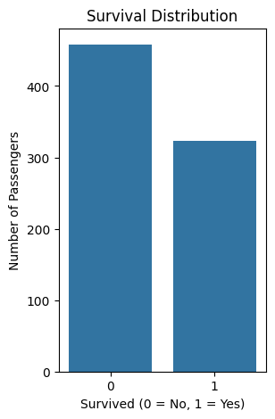
Figure 1. Survival distribution — Week 1 EDA (imbalance between survivors and non-survivors).
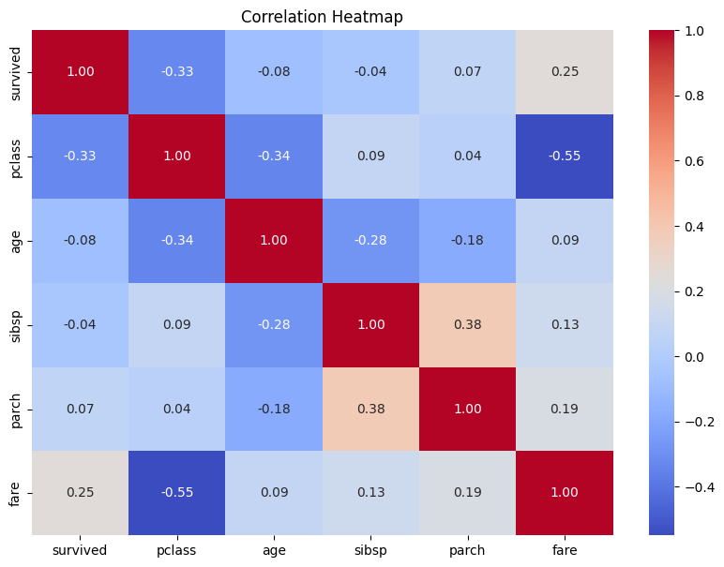
Figure 2. Correlation heatmap of numerical variables — Week 1 EDA.

4.3 Week 1 Conclusion
Week 1 established a clean, validated foundation dataset with zero missing values and zero duplicates. The exploratory analysis surfaced gender, passenger class, and age as the variables most likely to explain survival outcomes — hypotheses that were carried forward and formally tested in Week 3, and later used as predictive features in Week 4.

5. Advanced Data Visualization and Storytelling
Week 2 converted the cleaned dataset into a five-chart visual narrative aimed at a non-technical audience, moving deliberately from the overall outcome to group-level and multivariate detail: (1) survival distribution, (2) survival by gender, (3) survival by passenger class, (4) age distribution by survival, and (5) a combined age–fare–survival scatter plot.

5.1 Narrative Structure
Bar charts were used for categorical group comparisons, histograms for distributional shape, and a scatter plot for the joint relationship between two numerical variables and the binary outcome. This progression — outcome, then group differences, then demographic and numerical relationships — helps a reader absorb the main pattern before exploring the factors associated with it.
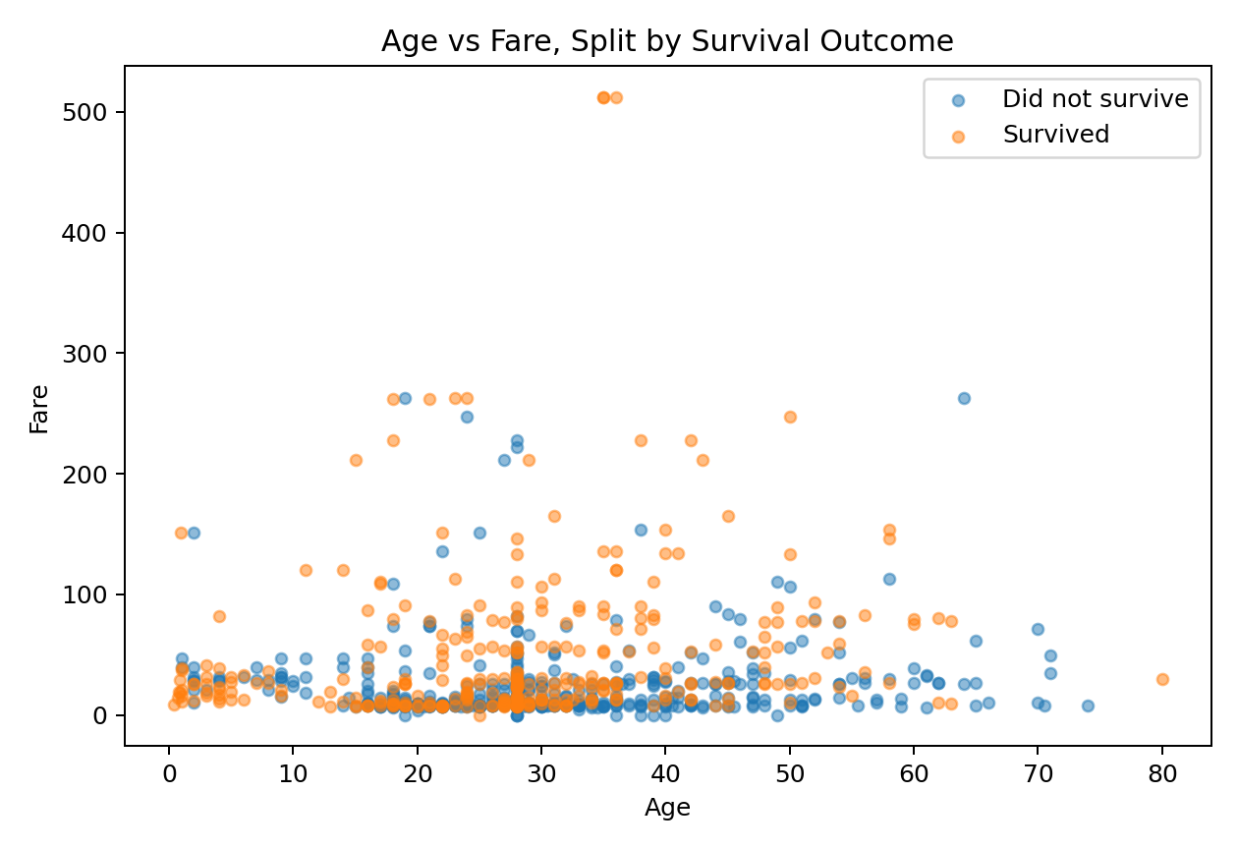
Figure 3. Age vs. Fare, colored by survival status — Week 2 visual story.

5.2 Key Insights from the Visual Narrative
- Overall survival rate in the cleaned dataset is approximately 41.4%, confirming the Week 1 finding.
- Survival rates differ substantially between gender groups — a pattern strong enough to warrant formal statistical testing.
- Passenger class shows a clear, graded relationship with survival across first, second, and third class.
- Passenger age spans roughly 0–80 years, enabling meaningful age-based segmentation.
- Fare varies considerably and, combined with age, reveals passengers of higher apparent status clustering toward better survival outcomes.
Critically, the Week 2 report notes that these visualizations reveal association, not causation — a distinction that motivated the formal hypothesis testing carried out in Week 3.

6. Statistical Analysis and Hypothesis Testing
Week 3 formally tested the two relationships flagged by the Week 1–2 exploratory work: whether gender is associated with survival, and whether mean age differs between survivors and non-survivors. Both hypotheses were tested at a significance level of α = 0.05 using the cleaned, duplicate-free dataset (zero missing values, zero duplicate rows confirmed prior to testing).

6.1 Descriptive Baseline
Gender | Did Not Survive | Survived | Survival Rate
Female | 76 | 217 | 74.06%
Male | 382 | 106 | 21.72%

6.2 Chi-Square Test of Independence — Gender vs. Survival
H0: Gender and survival are independent. H1: Gender and survival are not independent.
contingency_table = pd.crosstab(df["sex"], df["survived"])
chi2, p_value, dof, expected = chi2_contingency(contingency_table)
Result: χ² = 204.64, df = 1, p = 2.027e-46. Because p is far below 0.05, the null hypothesis is rejected — there is very strong statistical evidence of an association between gender and survival.

6.3 Welch's Independent Two-Sample T-Test — Age vs. Survival
H0: Mean age of survivors equals mean age of non-survivors. H1: The means differ.
t_stat, t_p_value = ttest_ind(
survived_age, not_survived_age, equal_var=False
)
Result: mean age of survivors = 28.32 years, non-survivors = 30.54 years; t = -2.210, p = 0.0275. The null hypothesis is rejected at α = 0.05. The 95% confidence interval for the mean difference (survivors minus non-survivors) is [-4.19, -0.25] years, and because this interval excludes zero, it corroborates the t-test conclusion.
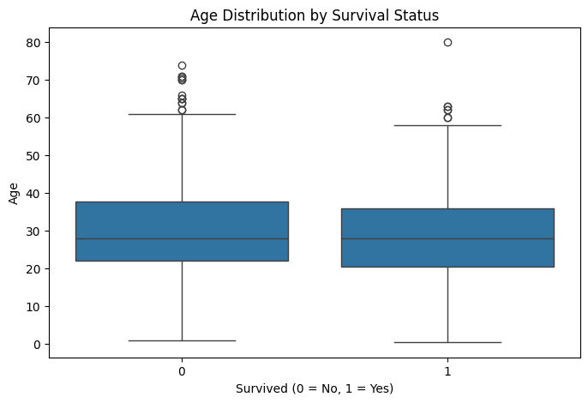
Figure 4. Age distribution by survival status — Week 3 box plot evidence.

6.4 Statistical Results Summary
Test | Statistic | p-value | Decision (α=0.05) | Conclusion
Chi-Square: Gender vs. Survival | χ²=204.64 | 2.027e-46 | Reject H0 | Significant association
Welch t-test: Age vs. Survival | t=-2.210 | 0.0275 | Reject H0 | Significant mean-age difference

Statistical significance strengthens what the Week 2 charts suggested, but it should not be confused with causation or practical importance — other factors, including passenger class, may also contribute to the observed differences.

7. Machine Learning Model Development and Evaluation
Week 4 operationalized the insights from Weeks 1–3 by training a Logistic Regression classifier to predict passenger survival. Logistic Regression was chosen as a baseline because the target is binary and the model produces interpretable coefficients.

7.1 Feature Engineering and Train-Test Design
Eight predictors were retained: pclass, age, sibsp, parch, fare, and one-hot-encoded categories sex_male, embarked_Q, and embarked_S (first category dropped in each case). The 781-row feature matrix was split 80:20 (random_state=32) with stratification on the target, producing a 157-row test set that preserved the original class balance.

7.2 Model Performance
77.56%  Train Acc. | 78.34%  Test Acc. | 72.46%  Precision | 76.92%  Recall | 74.63%  F1-Score | 0.854  ROC-AUC

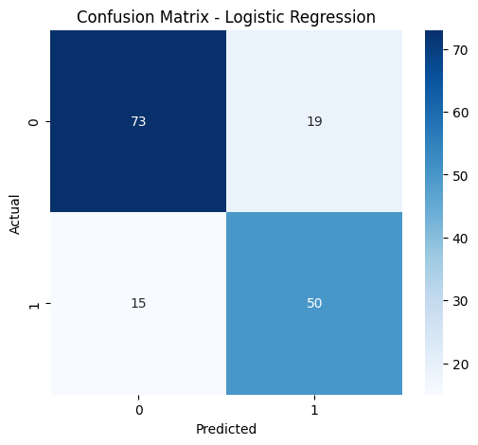
Figure 5. Confusion matrix — Logistic Regression (73 TN, 19 FP, 15 FN, 50 TP).
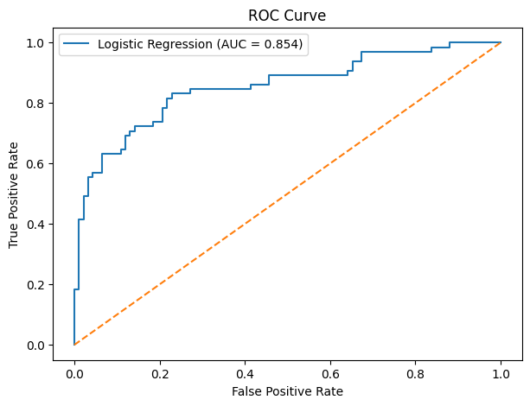
Figure 6. ROC curve — Logistic Regression (AUC = 0.854).
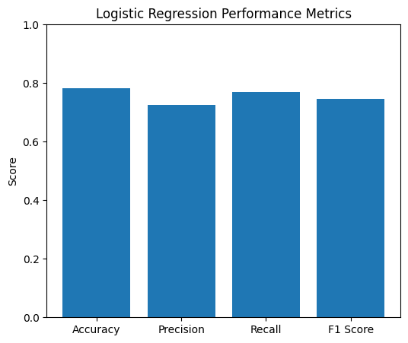
Figure 7. Accuracy, precision, recall, and F1-score comparison.

7.3 Confusion Matrix and Error Analysis
Of 157 test observations, the model correctly classified 123 (73 true negatives, 50 true positives) and misclassified 34 (19 false positives, 15 false negatives). The classification report shows class 0 (did not survive) achieving precision 0.83 / recall 0.79 / F1 0.81 across 92 cases, and class 1 (survived) achieving precision 0.72 / recall 0.77 / F1 0.75 across 65 cases.

7.4 Feature Coefficients
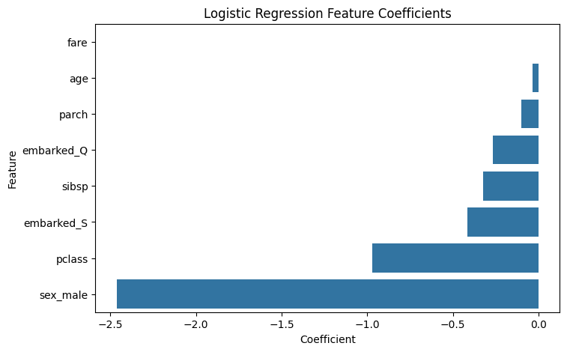
Figure 8. Logistic Regression feature coefficients.
sex_male carried the largest negative coefficient (-2.464), followed by pclass (-0.972), indicating that being male and traveling in a lower (higher-numbered) class were the strongest predictors of reduced survival odds in this fitted model. Fare contributed a small positive coefficient (0.0014); age (-0.0337), parch (-0.0983), sibsp (-0.3236), embarked_Q (-0.2677), and embarked_S (-0.4148) were all mildly negative. These are model coefficients from a single fitted split and should be read as directional associations, not causal effects.

7.5 Overfitting Assessment
Training accuracy (77.56%) was marginally lower than testing accuracy (78.34%) on this split, so the recorded results show no evidence of severe overfitting. A single train-test split, however, is not sufficient on its own to establish generalization performance — cross-validation would provide a more robust estimate, as discussed in Section 10.

8. Consolidated Key Findings
Viewed together, the four project stages converge on a consistent and mutually reinforcing set of findings about the Titanic dataset:

8.1 Cross-Stage Findings
- Data quality: The raw dataset's missingness was concentrated and addressable — median/mode imputation and a placeholder category for deck resolved all gaps without fabricating information, yielding a fully clean, duplicate-free base for every downstream stage.
- Gender is the single strongest signal: Identified visually in Week 2 (74.06% vs. 21.72% survival by gender), confirmed statistically in Week 3 (χ²=204.64, p<0.001), and confirmed again as the dominant predictor in the Week 4 model (largest-magnitude coefficient, -2.464).
- Passenger class is a consistent secondary signal: Visible in the Week 2 class-based bar chart and the second-largest coefficient in the Week 4 model (-0.972), pointing to socioeconomic status as an important, learnable factor.
- Age contributes a real but smaller effect: Statistically significant in Week 3 (t=-2.210, p=0.0275, ~2.2-year mean difference) but comparatively minor in the fitted model coefficient (-0.0337), suggesting its influence is partly captured through its correlation with other features.
- The full pipeline is coherent end-to-end: Every pattern surfaced in exploration was independently corroborated by formal testing and then shown to carry genuine predictive weight in the trained model — validating the internship's staged methodology as sound practice, not just an academic exercise.

8.2 Model Reliability Snapshot
Dimension | Result | Assessment
Discrimination (ROC-AUC) | 0.854 | Strong for a linear baseline
Overall accuracy | 78.34% | Solid, above naive-baseline performance
Class balance handling | Stratified 80:20 split | Preserves target distribution
Generalization evidence | Single split only | Directionally reassuring, not conclusive

9. Strategic Recommendations
The following recommendations translate the technical findings into concrete guidance for stakeholders evaluating how to act on, extend, or apply this analysis.

9.1 Recommendation 1 — Prioritize Demographic Segmentation
Given that gender and passenger class are both statistically validated and the two most influential predictive features, any downstream decision-making, resource-allocation, or policy application built on this type of analysis should segment outcomes by these two variables first, before layering in secondary factors such as age or fare.
- Action: Build reporting dashboards that default to gender × class cross-tabulations for any outcome metric.
- Rationale: These two variables jointly explain the majority of the variation in the observed outcome.

9.2 Recommendation 2 — Adopt a Two-Tier Modeling Strategy
Retain the Logistic Regression model as an interpretable, auditable baseline for stakeholder-facing decisions, while investing in ensemble methods (Random Forest, Gradient Boosting) for use cases where raw predictive accuracy matters more than explainability.
- Action: Deploy Logistic Regression where coefficient transparency is required (e.g., regulatory or executive reporting).
- Action: Benchmark tree-based ensembles and cross-validated performance before committing to a production model.

9.3 Recommendation 3 — Institutionalize the Four-Stage Pipeline
The acquisition → visualization → statistical validation → modeling sequence used across Weeks 1–4 proved effective at surfacing, confirming, and operationalizing insight in a traceable way. This sequence should be adopted as a standard template for future analytics projects.
- Action: Codify the pipeline as an internal playbook, with the cleaning and validation checks from Week 1 as a mandatory first gate.
- Action: Require that any visual pattern proposed for a business decision first pass a formal hypothesis test, as demonstrated in Week 3.

9.4 Recommendation 4 — Invest in Model Robustness Before Deployment
Before any operational use of the Week 4 model, apply k-fold cross-validation and compare against at least one ensemble alternative, given that the current evaluation rests on a single train-test split.
- Action: Run 5- or 10-fold cross-validation to obtain a distribution of performance estimates, not a single point estimate.
- Action: Evaluate calibration and threshold selection if the model will drive probability-based decisions rather than simple classification.

10. Business and Research Impact
Although the Titanic dataset is historical, the analytical workflow demonstrated here generalizes directly to modern business and research settings.

10.1 Business Applications
- Customer analytics: Chi-Square tests can evaluate whether outcomes (churn, conversion, complaint rate) differ significantly across customer segments, regions, or product lines, exactly as gender was tested against survival here.
- Operational metrics: T-tests can compare continuous measures — average spend, response time, resolution time — between two groups, mirroring the age-vs-survival comparison.
- Risk and safety scoring: A Logistic-Regression-style classifier, built on a small set of interpretable, well-encoded features, can provide an auditable baseline risk score before more complex models are justified.

10.2 Research and Scientific Applications
- The staged clean-visualize-test-model workflow supports evidence-based comparison of groups in any observational dataset, helping distinguish genuine patterns from random variation.
- Reporting both effect sizes (survival-rate differences, mean-age differences, confidence intervals) and significance levels supports rigorous, reproducible scientific communication.

11. Limitations and Future Improvements

11.1 Limitations
- The Titanic dataset is historical and demographically specific; findings should not be generalized to modern populations or unrelated domains without revalidation.
- Statistical association (Section 6) does not establish causation — other unmeasured or interacting variables may explain part of the observed relationships.
- Age values were imputed during Week 1 cleaning; downstream statistical and modeling results involving age are therefore partly dependent on that preprocessing choice.
- The Week 4 model was evaluated on a single 80:20 train-test split; performance estimates may be sensitive to the particular random partition (random_state=32).
- Logistic Regression assumes a linear decision boundary in the encoded feature space and may not capture nonlinear interactions between variables (e.g., class and fare jointly).
- The analysis focuses primarily on two-variable relationships in the statistical testing stage; a full multivariable or interaction-effects model was outside this project's scope.

11.2 Recommended Future Work
- Apply k-fold cross-validation to obtain more stable, split-independent performance estimates for the classifier.
- Benchmark Logistic Regression against Decision Tree, Random Forest, and Gradient Boosting classifiers on the same feature set.
- Conduct hyperparameter tuning (e.g., regularization strength) and assess its effect on test performance.
- Extend the statistical testing stage to multivariable methods (e.g., logistic regression with inferential statistics, ANOVA across class groups) to test for interaction and confounding effects.
- Engineer additional features (e.g., family size from sibsp/parch, title extracted from name) and evaluate their incremental value.

12. Conclusion
This five-week project successfully demonstrated a complete, end-to-end data science workflow: acquiring and rigorously cleaning a real-world dataset, communicating its patterns through a deliberate visual narrative, validating those patterns with formal statistical hypothesis tests, and operationalizing the resulting insight in a predictive machine learning model. Each stage's output fed directly and traceably into the next, and the final Logistic Regression classifier — achieving 78.34% test accuracy and a ROC-AUC of 0.854 — provides tangible evidence that the earlier exploratory and statistical work correctly identified the variables that matter most: gender, passenger class, and, to a lesser degree, age.
Beyond the specific Titanic findings, the project's greatest deliverable is the validated methodology itself: a repeatable, auditable pipeline that moves from raw data to a defensible, interpretable predictive model, accompanied at every stage by transparent documentation of decisions, code, and limitations. The strategic recommendations in Section 9, together with the future-work items in Section 11.2, provide a clear path for extending this work toward production-grade robustness.

Acknowledgment of Workload
This report consolidates and builds upon the technical work completed in Weeks 1 through 4, integrating prior analysis, visual evidence, and code within the prescribed 30–35 hour internship workload for the reporting task.

13. Appendix: Consolidated Code Reference

A.1 Data Loading and Cleaning (Week 1)
import pandas as pd
import numpy as np
import matplotlib.pyplot as plt
import seaborn as sns
df = pd.read_csv("titanic.csv")
df["age"] = df["age"].fillna(df["age"].median())
df["embarked"] = df["embarked"].fillna(df["embarked"].mode()[0])
df["embark_town"] = df["embark_town"].fillna(df["embark_town"].mode()[0])
df["deck"] = df["deck"].fillna("Unknown")
df.to_csv("titanic_cleaned.csv", index=False)

A.2 Statistical Testing (Week 3)
from scipy.stats import chi2_contingency, ttest_ind
contingency_table = pd.crosstab(df["sex"], df["survived"])
chi2, p_value, dof, expected = chi2_contingency(contingency_table)
survived_age = df[df["survived"] == 1]["age"]
not_survived_age = df[df["survived"] == 0]["age"]
t_stat, t_p_value = ttest_ind(survived_age, not_survived_age, equal_var=False)

A.3 Model Training and Evaluation (Week 4)
from sklearn.model_selection import train_test_split
from sklearn.linear_model import LogisticRegression
from sklearn.metrics import (accuracy_score, precision_score,
recall_score, f1_score, roc_auc_score, confusion_matrix)
X = pd.get_dummies(df[["pclass","sex","age","sibsp","parch",
"fare","embarked"]], drop_first=True)
y = df["survived"]
X_train, X_test, y_train, y_test = train_test_split(
X, y, test_size=0.2, random_state=32, stratify=y)
model = LogisticRegression(max_iter=1000)
model.fit(X_train, y_train)
preds = model.predict(X_test)

A.4 Source Reports Consolidated in This Document
Source File | Week
Week_1_Titanic_Data_Acquisition_Cleaning_EDA_Report.docx | Week 1
Week_2_Advanced_Data_Visualization_Titanic.docx | Week 2
Statistical_Analysis_Report.docx | Week 3
Week_4_Machine_Learning_Model_Development_and_Evaluation_Report.docx | Week 4

